

**Version History**

**SCTK2269-** **BRS - Simpliance Website Enhancements**

Version : 2.0

Document Type : Knowledge Document

Created By : Subramanya Raju E

Reviewed By : Ayesha Bareen

Reviewed Date : 02-11-2023

BRS - Simpliance Website Enhancements

|  |  |  |  |  |  |  |
| --- | --- | --- | --- | --- | --- | --- |
| **Date** | **Version** | **Creator** | **Reviewer** | **Approver** | **UAT POC** | **History Details** |
| 27-Jun-23 | 1 | Subramanya Raju | Ayesha Bareen | Hansa Sharma | - | Creation |
| 02-Nov-23 | 2 | Raj Kumar K | Ayesha Bareen | Rajesh C | Kumar Karthick Raj | Added **Privacy Policy & Terms & Conditions** information and hyperlink on all the product enquiry Form submission. |
| 16-Nov-23 | 3 | Raj Kumar K | Ayesha Bareen | Rajesh C | Kumar Karthick Raj | Added **Terms & Conditions** information and hyperlink on all the product enquiry Form submission for SOC 2. |
| 11-12-2023 | 4 | Raj Kumar K | Fazeela S | Ayesha B | Fazeela S | Added 7 & 8 points changes to update the contact details on website. |

Table of Contents

**1.** **Introduction:** 4

**2.** **Home Page:** 4

**3.** **Internal Pages:** 5

**4.** **Menu Bar** 7

**5.** **Footer Section:** 7

**6.** **Products Enquiry Form Submission - Adding Privacy Policy info on Submit button:** 8

1. **Introduction:**
   1. The document describes the enhancements to Simpliance Website.
2. **Home Page:**
   1. URL: https://www.simpliance.in/

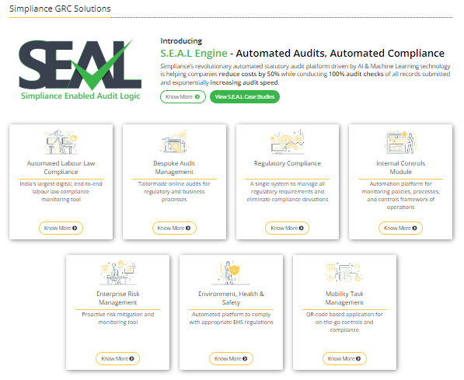

* + 1. Remove the following cards under Simpliance GRC section.
       1. The Internal Controls Module,
       2. Enterprise Risk Management,
       3. Environment, Health and Safety
       4. Mobility Task Management
    2. Rename the header of the following cards under Simpliance GRC section.
       1. Automated Labour Law Compliance to be renamed as Simpliance Classic
       2. Bespoke Audit Management as Simpliance Audit Module
       3. Regulatory Compliance as Simpliance Remo
    3. Ribbon button to be renamed from Request SEAL Demo as “Business Enquiry Form”.

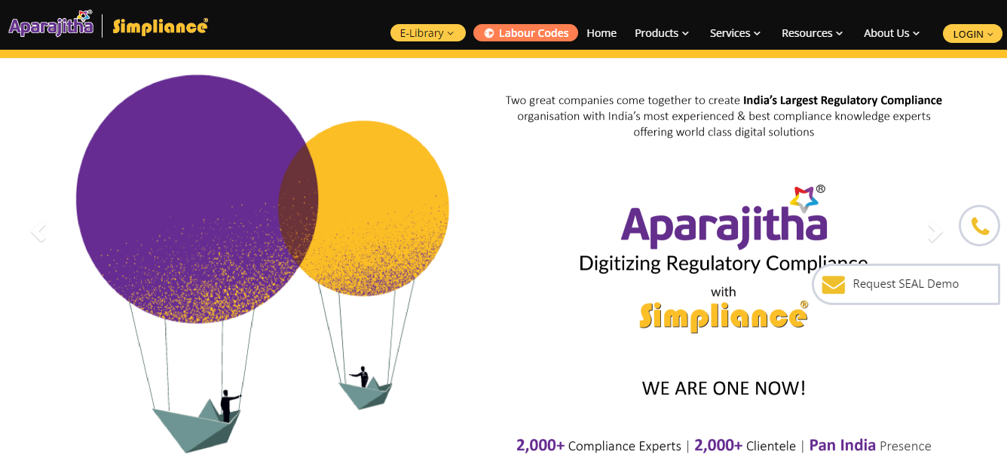

* + 1. When any demo request is submitted by any visitor, capture the page URL in database and show the URL in the email request that is forwarded to Sales team.

1. **Internal Pages:**
   1. URL: <https://www.simpliance.in/simpliance-classic>
      1. Rename the highlighted text to Simpliance Classic.

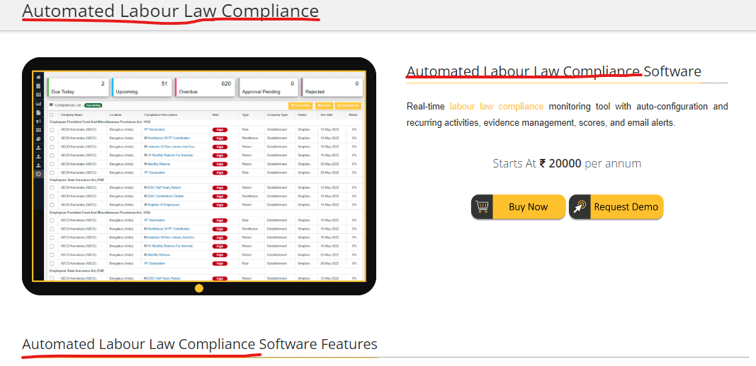

* 1. URL: <https://www.simpliance.in/temp_orders/demo_request/1>
     1. Rename the highlighted text to Simpliance Classic.

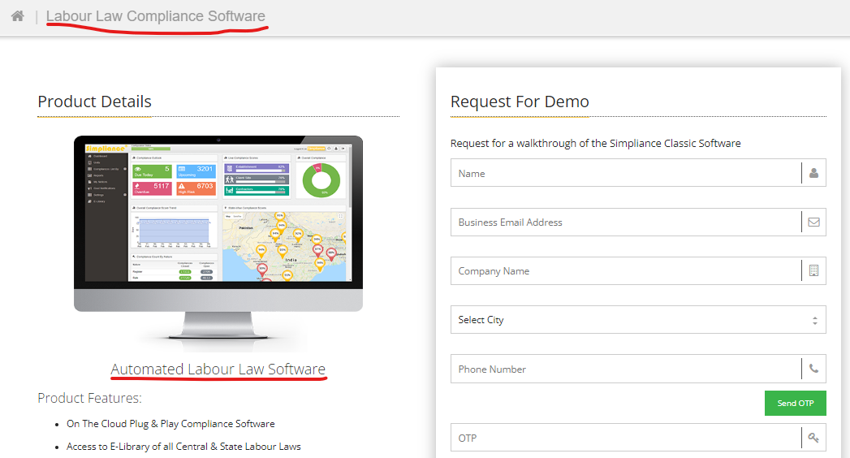

* 1. URL: <https://www.simpliance.in/internal-audit-management>
     1. Rename highlighted text in below image to Simpliance Audit Module

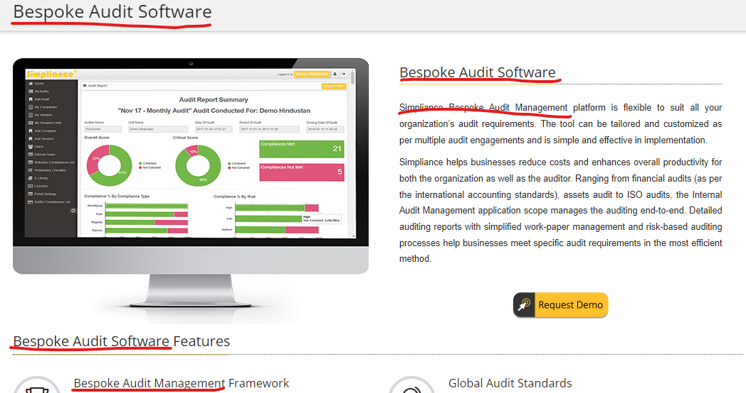

* 1. URL: <https://www.simpliance.in/regulatory-compliance-management>
     1. Rename highlighted text in below image to Simpliance Remo

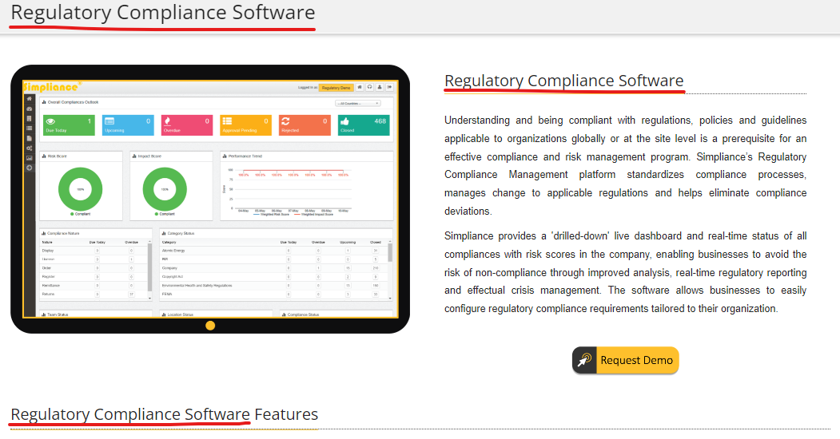

* 1. URL: <https://www.simpliance.in/temp_orders/demo_request/5>
     1. Rename highlighted text in below image to Simpliance Remo

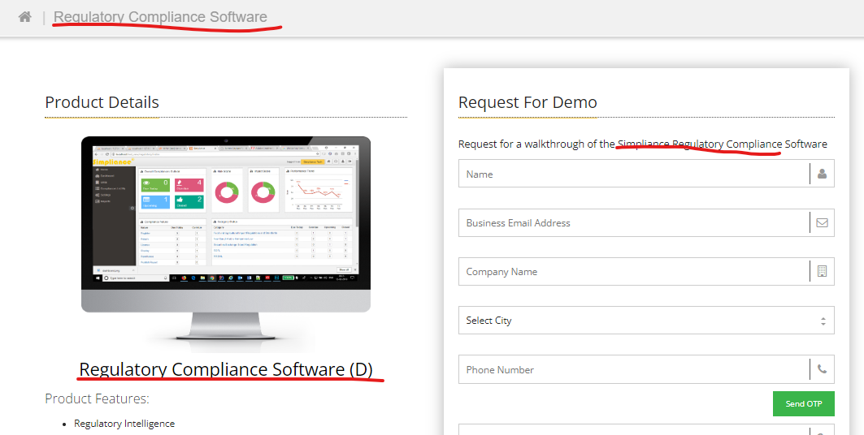

* 1. URL: <https://www.simpliance.in/professional-tax>
     1. Change the text to “Subscribe Now” and remove cart icon and @ 5000 per year.

Note: This is a common element, this change must reflect in all related pages where the element is placed.

1. **Menu Bar**
   1. Remove “Internal Controls Module” option from the Products Menu drop down.
   2. Add new menu as “Countries” and show “Sri Lanka” as drop down.
   3. Provide redirection to <https://lk.simpliance.in/>

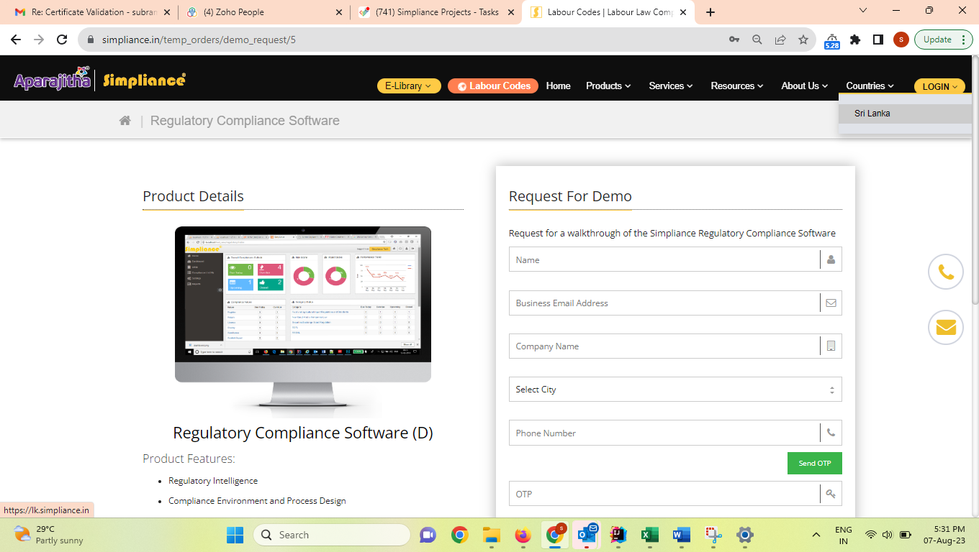

1. **Footer Section:**
   1. Sales Enquiry – change email id from [marketing@aparajitha.com](mailto:marketing@aparajitha.com) to [sales@aparajitha.com](mailto:sales@aparajitha.com)
   2. Technical Support – change email id from [helpdesk@simpliance.in](mailto:helpdesk@simpliance.in) to [customersupport@aparajitha.com](mailto:customersupport@aparajitha.com)
2. **Products Enquiry Form Submission - Adding “Privacy Policy “ and “Terms & Conditions” info on Submit button:**
   1. Show the default note “By proceeding, you are indicating your acceptance of the Simpliance [Privacy Policy](https://www.simpliance.in/privacy-policy) and [Terms & Conditions](https://www.simpliance.in/terms)” on all the product Collection points on website FORMS.

**Condition:** Plain text only with hyperlink on “Privacy Policy” and “Terms & Conditions”.

Ex: <https://www.simpliance.in/temp_orders/demo_request/3>

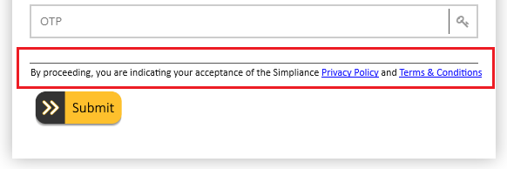

* 1. Add the link below as hyperlink to the text “Privacy Policy”.

Link <https://www.simpliance.in/privacy-policy>

**Condition:** On click of Privacy Policy, open the link in new tab.

* 1. Add below link as hyperlink to the text “Terms & Conditions”.

Link <https://www.simpliance.in/terms>

**Condition:** On click Terms & Conditions, open the link in new tab.

1. Update the phone number in page <https://simpliance.in/labour-codes>

New Phone #: +91 74181 33323

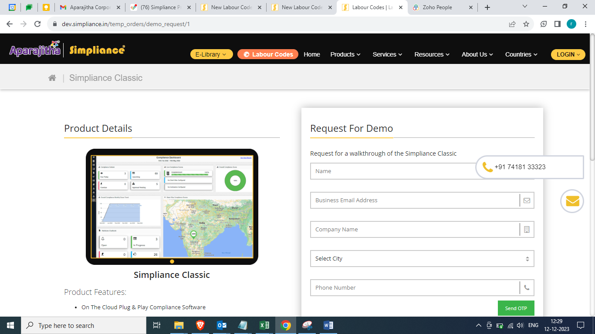

1. Update the contact information as below on the page <https://simpliance.in/contact-us>

For, Business Queries marketing@aparajitha.com

+91 74181 33323

+91 99949 39987

For, Recruitment Queries - recruitment@aparajitha.com

For, Technical Support - customersupport@aparajitha.com

For, PR Queries - Mohamed Faisal faisal@aparajitha.com

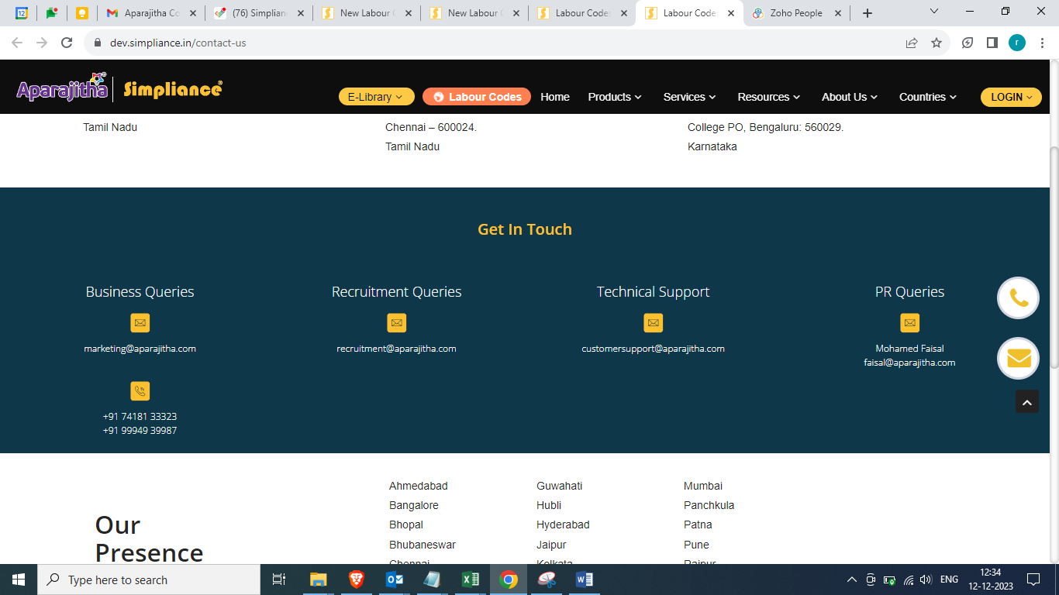

*** End of document ***